Program Summary:

In partnership with the South Carolina Alliance for Recovery Residences (SCARR), Oxford House International (OHI), and our network of community providers across the state, the S.C. Department of Alcohol and Other Drug Abuse Services (DAODAS) proposes the South Carolina Recovery Housing Program (RHP) in response to the Department of Housing and Urban Development (HUD) Federal Register Notice No. FR-6225-N-01.

For many individuals, achieving and maintaining recovery from a substance use disorder (SUD) is hindered by a lack of safe, affordable housing that is supportive of the recovery process. Recovery housing extends the continuum of care to provide support to individuals as they initiate, stabilize, and maintain long-term recovery in the community. As the Single State Agency for Substance Abuse Services (SSA) in South Carolina, DAODAS will bring partners together to provide stable, transitional housing for individuals in recovery from an SUD. We will enhance physical and psychological safety through supportive transitional housing and short-term housing assistance and assist the public by improving their well-being through linkage to an array of wrap-around support services.

Through the implementation of recovery housing vouchers from RHP funds, DAODAS will seek to address this gap and provide for greater access across all racial, ethnic, and socioeconomic populations in the state. Safe, stable recovery-focused housing addresses foundational physiological and safety needs, and removes barriers traditionally set in place by an individual’s Social Determinants of Health.

DAODAS plans to provide applications for housing vouchers via the agency’s website. Applications will be submitted, reviewed, approved or denied, and correspondence sent to applicants as well as housing providers (as necessary). If an application is denied, an electronic communication will be sent informing the applicant and describing the reason(s) for denial. If approved, notifications – along with process logistics – will be communicated electronically to both the applicant and the housing provider when selected.

Through extensive work, DAODAS has developed significant partnerships that address the diverse needs of those entering and residing in recovery housing across South Carolina. Key partners include SCARR, OHI, S.C. Department of Commerce, S.C. Department of Corrections, as well as county alcohol and drug abuse authorities throughout the state. Many of these partners, existing and new, will be part of our advisory council for this program and serve as referring agencies. As experts in recovery housing and SUD treatment and recovery services, each entity and their respective designees bring a wealth of experience and knowledge to bear when serving the public. This system will develop a comprehensive network of partners in recovery housing to address the well-being of participants and promote long-term recovery.

The focus of this initiative is to provide access to safe and stable recovery-supportive housing, while helping increase access to recovery-supportive wrap-around services. Additional key performance outcomes include helping individuals secure permanent housing, gaining employment, engaging in recovery support services, and ascertaining the demographic makeup of those in the program.

The South Carolina RHP will utilize statewide support to address the key gap in access to recovery housing in South Carolina. Safe and stable housing is an essential component to sustained recovery from an SUD. This application’s award of $790,557.00 under the Federal Fiscal Year 2021 (FFY21) Recovery Housing Allocation and $823,245.00 under the Federal Fiscal Year 2022 (FFY22) allocation will be used in the furtherance of the nationwide objectives set forth in the announcement. During the life of this funding, DAODAS anticipates serving 700 unique individuals, helping 70 unique individuals secure permanent housing, increasing access to recovery-support services for 560 individuals, and helping 350 individuals gain employment.

Need
There are more than 378,000 individuals in recovery from an SUD in South Carolina and 808 beds that meet national standards available to the public. The S.C. Revenue and Fiscal Affairs Office reports that 703,004 residents of the state were living in poverty as of 2020. This is 13.8% of the population. While national averages report that between 9% and 10% of the population have SUD challenges, some studies place the percentages for those experiencing poverty as high as 12.6% (Thompson, et. al., 2013). Using the modest 9% figure, statistics imply that 63,270 people living in poverty in South Carolina have an SUD. This presents a significant barrier for those with an SUD who are living in poverty to obtain safe and supportive housing. Additionally, lack of ability to pay for housing places other significant burdens on those who have been provided “provisional” or short-term subsidized admittance. With a focus centered on gaining immediate employment in order to maintain shelter, individuals are not afforded the opportunity to explore all possible recovery-supportive services available to them. This shifts the individual’s focus from recovery to employment. By providing for longer-term rental subsidies, the individual in recovery is afforded the opportunity to have their basic needs met and focus their attention on their SUD needs.

Geographic Distribution
South Carolina recovery residences that meet national standards are centralized in 13 counties. These counites span all four regions of the state – the Upstate, Lowcountry, Pee Dee, and Midlands.

Populations Served
Oxford House in South Carolina serves men, women, and women with children. Oxford House currently has 439 beds for men, 136 beds for women, and 103 beds for women with children. The number of beds dedicated to women with children constitutes a significant gap across the state. SCARR-certified houses offer 109 beds for men and 21 beds for women, but these houses do not currently provide any beds for women with children. Funds from the RHP will help us reach those individuals in the state whose social determinates of health have traditionally precluded, or significantly hindered, their ability to secure safe and stable housing along with wrap-around recovery support services. This has been especially true of underserved populations, including African Americans, the Latinx populations, LGBTQ+ populations, and citizens returning from incarceration.
Resources:

DAODAS partners with other state agencies, non-profit organizations, private organizations, and county agencies to provide resources and services for those seeking and/or maintaining recovery from an SUD.

DAODAS is the SSA for South Carolina and is tasked with the administration of prevention, treatment, recovery, and compliance needs for federally funded SUD providers throughout the state. DAODAS administers funding and compliance for 31 county agencies that deliver direct services to all 46 counties. As such, DAODAS serves as the fiduciary agency that administers multiple federal grants. Many of these support initiatives consistent with the goals of the RHP, such as the Substance Abuse Prevention and Treatment Block Grant (SABG) from the Substance Abuse and Mental Health Services Administration (SAMHSA), as well as the State Opioid Response Grant (SOR) from SAMHSA and its predecessor, the State Targeted Response Grant (STR). Through these funding sources, DAODAS provides financial mechanisms to deliver evidence-based practices for prevention, treatment, and recovery-support services. These organizations provide the wrap-around services needed for those individuals seeking or maintaining recovery from an SUD. All 31 county agencies are CARF or Joint Commission accredited. Six of the nine recovery community organizations in the state are accredited by the Association of Recovery Community Organizations. The state’s opioid treatment providers (OTPs) are CARF accredited.

Administration Summary:

Jan Nerud, DAODAS Grants and Contracts Coordinator, will serve as the Project Director for South Carolina’s Recovery Housing Program. As the Project Director, his primary roles will be to ensure both fidelity and comprehensive coordination for application review, participant communication, and coordination of fund disbursement to all approved housing entities.
Mr. Nerud has B.S. in Psychology, has been certified as an Alcohol and Drug Counselor (CADC), has over five years of behavioral health experience, and is the current program director for all recovery housing projects in the state.

Jan Nerud
Grants and Contracts Coordinator
S.C. Department of Alcohol and Other Drug Abuse Services
PO Box 8268
Columbia, SC 29202
cell: 803.315.0359
jnerud@daodas.sc.gov

Use of Funds:

Use of Funds: FFY21
Method of Distribution Amounts
Total Award $790,557.00
Administrative Costs (5%) $ 39,527.85
Technical Assistance (3%) $ 23,716.71
Recovery Housing Vouchers $727,312.44

Use of Funds: FFY22
Method of Distribution Amounts
Total Award $823,245.00
Administrative Costs (5%) $ 41,162.25
Technical Assistance (3%) $ 24,697.35
Recovery Housing Vouchers $757,385.40

In compliance with award requirements, 30% of the funding for vouchers from the FFY21 allocation, totaling $237,167.10, will be expended within the first 12 months of program implementation. Additionally, in compliance with award requirements, 30% of the funding for vouchers from the FFY22 allocation, totaling $246,973.50, will be expended within the second 12 months of program implementation.

Eligibility
Applicants for the RHP must identify as being in recovery from an SUD and meet low-and-moderate income guidelines in accordance with the stated national objective. No funding will be disbursed directly to a participant. All payments will be made directly to houses certified through the SCARR, OHI, or rental sites with access to recovery support services provided by a DAODAS-funded initiative. Such rental site payments will only be made in a case where there are no SCARR-certified houses or Oxford Houses within a 50-mile radius of the participant’s location. Funds will be available for individuals for a period not greater than two years or until permanent housing is secured, whichever occurs first.

Definitions:
(1) Individual in recovery.
(2) Substance use disorder.

For the purpose of this award, DAODAS has adopted and adapted two definitions by SAMHSA as follows:
- An individual in recovery from a substance use disorder is a person who is in the process of change to improve their health and wellness, live a self-directed life, and strive to reach their full potential.
- A substance use disorder is the continual use of alcohol and/or other drugs in such a way that causes clinically significant impairment. This impairment includes, but is not limited to, physical and mental health, as well as impacts on social, economic, and familial life.

Anticipated Outcomes and Expenditure Plan:

Expenditure Plan
DAODAS will comply with all guidelines set forth in the RHP award notification. DAODAS will spend at least 30% of the award in the first 12 months of plan implementation. DAODAS plans to utilize 100% of funds prior to the conclusion of the performance period, September 1, 2027, and acknowledges that Section 8071(d)(2) states that no matching funds are required. The need to provide access to safe and stable recovery-focused housing is a substantial gap in South Carolina. DAODAS does not anticipate any significant barriers to expending all RHP funds. DAODAS’ administrative costs shall not exceed 5% of the total award, and technical assistance costs shall not exceed the required 3% of the total award. There will be no income generated as a result of this initiative.

Outcomes
DAODAS will develop a comprehensive data collection, monitoring, and reporting mechanism that provides detailed information about the RHP’s impact on the state of South Carolina. DAODAS plans to track the number of individuals who gain access to safe and stable housing through RHP funds; the number of individuals who were able to transition to permanent housing that received RHP funds; the number of individuals engaged in recovery support services who received RHP funds; the number of individuals who became employed who received RHP funds; and the demographic makeup of individuals served through RHP funds. The Project Director will collect and analyze data to see if projected outcomes are being met. In order to track performance measures, everyone receiving vouchers will be made aware of a 3-month, 6-month, 12-month, 18-month and 24-month follow-up survey that will be required to maintain program compliance. For those individuals who utilize 24 months of funds or obtain permanent housing, voluntary satisfaction surveys will be sent to help evaluate participant perceptions of challenges and successes.

Objective | Projected Outcome
Number of individuals who gain access to safe and stable recovery-focused housing | 700
Number of individuals who transition to permanent housing after receiving RHP vouchers | 70
Number of RHP voucher awardees who engage in recovery support services | 560
Number of RHP voucher awardees who gain employment | 350
Demographic analysis of RHP voucher awardees | 700  (to be collected on applications)
The RHP Project Director understands the requirements for data collection and reporting, and as a result will report all performance measures in Disaster Recovery Grant Reporting (DRGR). Annual reports will include comparisons between proposed and actual metrics along with qualitative descriptions of program practices.

Citizen Participation Summary:

Below is a list of questions or comments received during the public comment period. As a result of the questions received, one substantial change has been made to the plan. Originally a 6-month, 12-month, 18- and 24-month survey was planned to be conducted with each participant. These surveys are mandatory for continued participation in the RHP program. After public comment, it was decided that an additional 3-month survey is in the best interest of the program. The questions/comments and their responses are as follows:

- Are you willing to fund out of state recovery residences?
South Carolina funds can only be utilized within the borders of South Carolina.
- However, what if the Oxford House is full?
“All payments will be made directly to houses certified through the SCARR, OHI, or rental sites with access to recovery support services provided by a DAODAS-funded initiative. Such rental site payments will only be made in a case where there are no SCARR-certified houses or Oxford Houses within a 50-mile radius of the participant’s location.”
- Could you include language for capacity issues which then may warrant consideration for a recovery house not SCARR certified?
“All payments will be made directly to houses certified through the SCARR, OHI, or rental sites with access to recovery support services provided by a DAODAS-funded initiative. Such rental site payments will only be made in a case where there are no SCARR-certified houses or Oxford Houses within a 50-mile radius of the participant’s location.”
- I just had a question regarding eligibility if recovery also includes individuals engaged in MAT services residing in Recovery Homes that have a harm reduction approach rather than abstinence-based?
“All payments will be made directly to houses certified through the SCARR, OHI, or rental sites with access to recovery support services provided by a DAODAS-funded initiative. Such rental site payments will only be made in a case where there are no SCARR-certified houses or Oxford Houses within a 50-mile radius of the participant’s location.”

- Who will make the decision if an individual qualifies and how quickly will that decision be made? Similarly, how will the decision be made as to how long someone can receive the funds?
The decision will be made by the Project Director at DAODAS. Applications will be reviewed, scored, and notification made within five business days. An individual may receive funds for up to 24 months or until permanent housing is established, whichever occurs first.
- I assume that the monthly amount of “rent” is a set amount such that all houses receive the same amount for housing an individual. That would be in line with the way that SOR dollars currently pay for the services the 301’s provide.
RHP Funds are not standardized, as that would be a barrier to services. The stated goal of the RHP award is to remove barriers and provide safe and stable housing to individuals in recovery who would otherwise not be able to access services.
- What type of oversight will the houses have to ensure they are not requiring the individual to pay in addition to receiving the grant funds?
Regular updates with recipients will take place at three-, six-, 12- and 18-month intervals to ensure program fidelity.
- If an individual is approved for the housing, how will the “rent” be paid? What mechanisms will be in place to ensure that DAODAS is paying only for the days the individual is there? I’ve heard that in some cases at some houses, the individual is given a scholarship by an entity and it is paid to the house but after a few days the individual leaves or the house kicks them out and the house still keeps the scholarship money?
Oxford House will submit monthly invoices to DAODAS with individual’s length of stay for reimbursement. SCARR will submit monthly requests to DAODAS from SCARR-certified houses with individual’s length of stay for reimbursement. Payments are made on a reimbursement basis.
- I know all houses do not allow a person to be on methadone or suboxone or they will accept someone on it but the person has to taper off within a 30 day period. Will those houses be eligible for this funding given that medication assisted treatment is now considered best practice from SAMHSA, ASAM and others?
No houses are eligible for funding. The individual is approved/denied funding. The funding follows the person, not a residence.
- Are there provisions for non-SCARR and non-Oxford houses as long as they are 50 miles away?
“All payments will be made directly to houses certified through the SCARR, OHI, or rental sites with access to recovery support services provided by a DAODAS-funded initiative. Such rental site payments will only be made in a case where there are no SCARR-certified houses or Oxford Houses within a 50-mile radius of the participant’s location.”

- Is there a provision for ensuring that recovery houses that get funding take folks who are taking MOUD?
No houses are eligible for funding. The individual is approved/denied funding. The funding follows the person, not a residence.
- We have some interim/transitional beds that are primarily for our current clients and those who complete services. Would we be eligible to apply for funding under this RFP?
No houses are eligible for funding. The individual is approved/denied for funding. The funding follows the person, not a residence.
- Comment: A suggestion to add the underlined/Bold: Through extensive work, DAODAS has developed significant partnerships that address the diverse needs of those entering and residing in recovery housing across South Carolina. Key partners include SCARR, OHI, statewide regional Recovery Community Organizations (RCOs), S.C. Department of Commerce, S.C. Department of Corrections, as well as county alcohol and drug abuse authorities throughout the state. Many of these partners, existing and new, will be part of our advisory council for this program and serve as referring agencies. As experts in recovery housing and SUD treatment and recovery services, each entity and their respective designees bring a wealth of experience and knowledge to bear when serving the public. This system will develop a comprehensive network of partners in recovery housing to address the well-being of participants and promote long-term recovery.
Thank you for the suggestion.
- Will this opportunity assist with the “resident’s” fees while in their residential program? As it pertain to assisting the resident with the first 2 or 3 months as they work towards self-sustainability or for financial assistance upon leaving the recovery housing?
“All payments will be made directly to houses certified through the SCARR, OHI, or rental sites with access to recovery support services provided by a DAODAS-funded initiative. Such rental site payments will only be made in a case where there are no SCARR-certified houses or Oxford Houses within a 50-mile radius of the participant’s location.”
- Do you believe the houses need to be certified through the certified housing process? If so, pass along to me the contact of starting that process.
“All payments will be made directly to houses certified through the SCARR, OHI, or rental sites with access to recovery support services provided by a DAODAS-funded initiative. Such rental site payments will only be made in a case where there are no SCARR-certified houses or Oxford Houses within a 50-mile radius of the participant’s location.” https://scarronline.org/
- (House Name) currently has a house not fully defined (right at this moment) should we have. Conversation as it pertain to providing beds for those with children. If this is the case I would need to have a conversation with our attorney office and insurance carrier.
DAODAS has no opinion on how your organizational structure should operate.
- Program residents, will they have access to funds (should they attend 301 agencies) through other grants in place for those without the ability to pay .. in order to attend 301 services? OR, will this grant funds be used to pay for the resident’s 301 service needs/
RHP funds are for recovery housing only. They are paid directly to the house that the recipient designates.
- Will, through the grant we all be able to provide Wrap Around services? Could your credential along with (House name’s) LPC in process provide required services in an effort of keeping more money within the organization?
RHP funds are for recovery housing only. RHP funds are not used to pay for direct services.

Partner Coordination:

Figure 1. County Alcohol and Drug Abuse Authority, and Opioid Treatment Provider locations as of August 2022
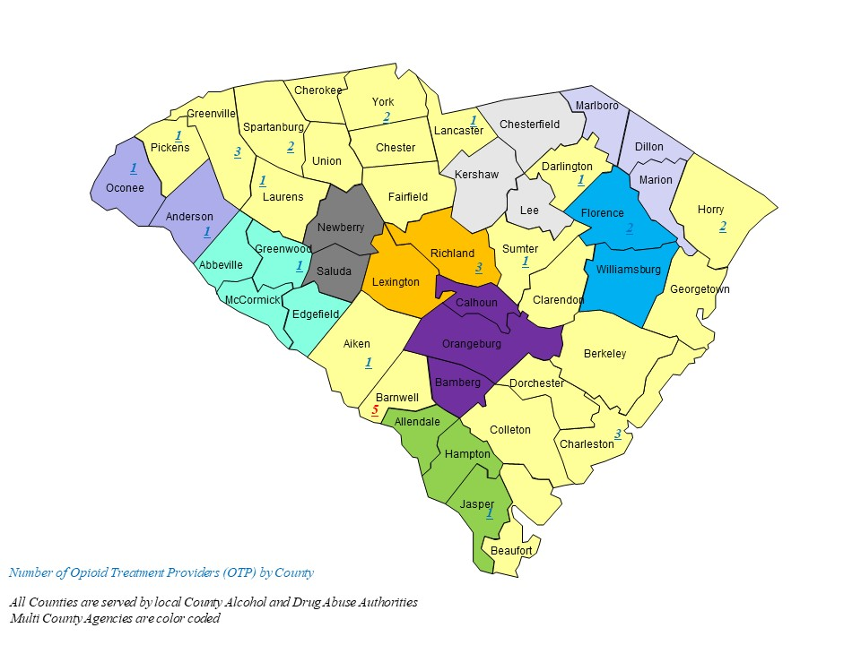

Figure 2. Recovery Residences in South Carolina by type and county
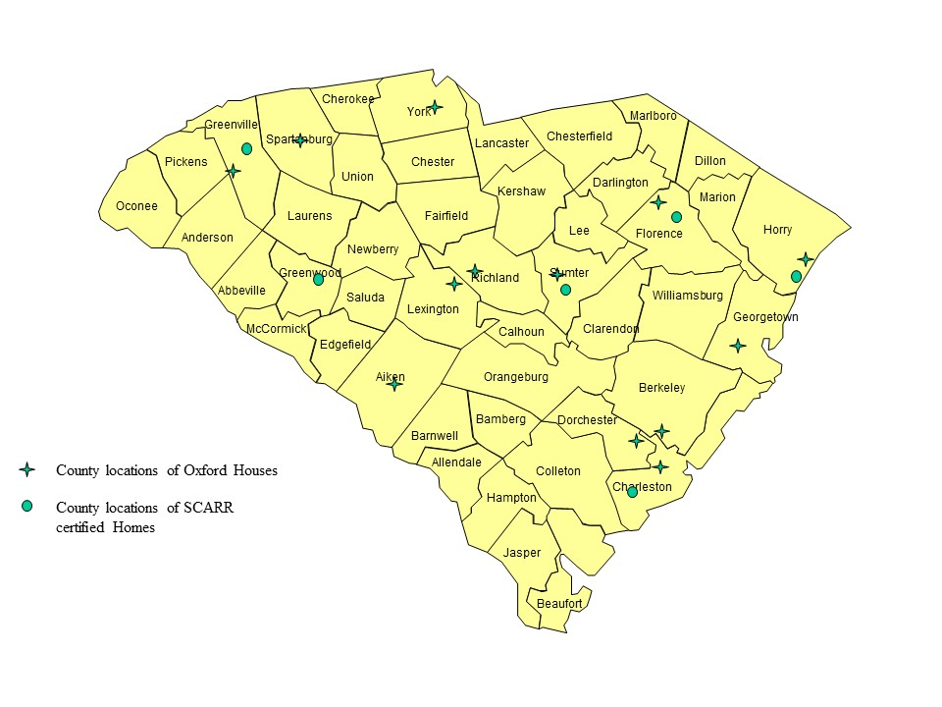

Figure 3. Recovery Community Organizations in South Carolina

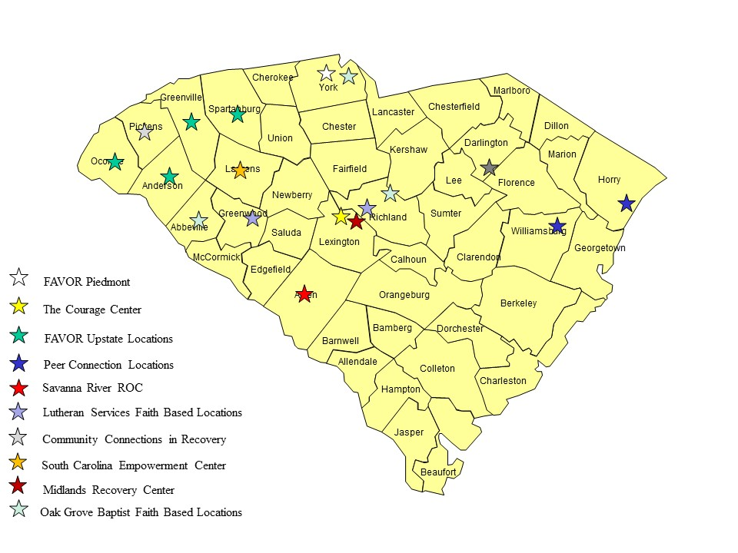

DAODAS has partnered with state, county, public, and private organizations for the successful implementation of increased access to recovery-focused housing and wrap-around services for South Carolina. Following are several of these organizations and the roles they play.

Oxford House
Oxford House is a long-standing housing concept in recovery from alcohol and other drug addiction. In its simplest form, an Oxford House describes a democratically run, self-supporting, substance-free home. The number of residents in a house may range from six to 15; there are houses for men, houses for women, and houses that accept women with children. DAODAS and Oxford House have maintained a strong relationship over the past 10 years, and as a result of this partnership, Oxford House has been able to grow in South Carolina and meet the ever-changing needs of those seeking safe and stable recovery-focused housing.

South Carolina Alliance for Recovery Residences (SCARR)
SCARR is a 501(c)(3) nonprofit organization that was formed in 2018 to serve the recovery community by providing a single point of access for information regarding recovery residences and related organizations in the state. The primary focus of SCARR is the development and maintenance of clear and consistent standards for recovery residences in South Carolina and using these standards as the basis for non-biased certification statewide. SCARR strives to maintain clear communication regarding these standards of care for recovery residences and the associated communities, while ensuring credibility, ethical conduct of members, and excellence in all interactions with the South Carolina recovery community.

As an affiliate of the National Alliance for Recovery Residences, SCARR is responsible for ensuring that the recovery residence certification process is consistent with the national standard.

County Alcohol and Drug Abuse Authorities
South Carolina contracts with 31 county agencies serving all 46 counties. Each organization provides comprehensive prevention, treatment, and recovery services through evidence-base practices. County authorities have medical, clinical, and peer support professionals on staff to ensure the highest level of efficacy in the delivery of direct services. DAODAS works closely with each agency on the framework for services, routinely provides technical assistance, and serves as the liaison between each agency and SAMHSA. These deep and lasting partnerships have built a bond of trust that benefits the public. The county agencies predominately see a low-moderate income population and will serve as a major source of recovery housing referrals for the RHP.

Recovery Community Organizations (RCOs)
An RCO is a community-based, non-profit, peer-run center for “all things recovery.” DAODAS funds nine RCOs that provide a broad scope of services to support those seeking and/or maintaining recovery. RCOs will be able to not only provide recovery services for those in recovery housing but serve as a referral source for those in need of safe and stable recovery housing.

S.C. Department of Corrections (SCDC)
DAODAS serves those currently incarcerated through a partnership with SCDC to provide peer support services to individuals “behind the wall.” This DAODAS initiative provides for medication-assisted treatment/recovery for those currently incarcerated and soon to be released. At this time, South Carolina boasts one of the lowest recidivism rates in the nation at a combined 23.1%. Those citizens returning from incarceration are in a greater need for increased access to safe and stable housing. Returning citizens are a priority focus for RHP funds.

Faith-Based RCOs
DAODAS recently awarded funds to three faith-based/focused RCOs. These are the first of their kind in South Carolina and will increase access and engagement of recovery support services available in the Midlands and Upstate regions. Faith-based/focused RCOs will be able to not only provide recovery services for those in recovery housing but will serve as a referral source for those in need of safe and stable recovery housing.

Opioid Treatment Programs (OTPs)
OTPs treat the public by assessing for, prescribing, and monitoring Food and Drug Administration (FDA)-approved medications for the treatment of opioid use disorder (OUD). An OTP provides counseling and education for a patient’s SUD needs, as well as the prevention of human immunodeficiency virus (HIV). OTPs can be a stable and convenient point of facilitation for the treatment of OUD through the use of medication.

Collegiate Recovery Programs (CRPs)
DAODAS funds three CRPs across the state that provide a full array of wrap-around services to students in recovery from an SUD. As RHP participants explore ways to improve their lives and reach their full potential, CRPs will potentially play a role in participant’s lives.

Subrecipient Management and Monitoring:

DAODAS has the capacity and ability to ensure RHP programmatic implementation, monitoring, and reporting requirements. There are no projected subrecipients for program implementation.

Pre-Award/Pre-Agreement Costs:

There are no pre-award or pre-agreement costs to be reimbursed with RHP funds.

Certifications:

Standard Forms 424 and 424D are attached. All required certifications can be found in the appendix.

